SOLUTION DESIGN DOCUMENT

Project:
Label Printing & Dispatch Solution

Customer:
DAIICHI N HORIZON.

Submitted By:


NOTICE
This document contains information, which is the proprietary property of SATO. This document is received in confidence and its contents cannot be disclosed or copied without the prior written consent of SATO.
Nothing in this document constitutes a guaranty, warranty, or license, express or implied. SATO disclaims all liability for all such guaranties, warranties, and licenses, including but not limited to: Fitness for a particular purpose; merchantability; not infringement of intellectual property or other rights of any third party or of SATO; indemnity; and all others. The reader is advised that third parties can have intellectual property rights that can be relevant to this document and the technologies discussed herein, and is advised to seek the advice of competent legal counsel, without obligation of SATO
SATO retains the right to make changes to this document at any time, without notice. SATO makes no warranty for the use of this document and assumes no responsibility for any errors that can appear in the document nor does it make a commitment to update the information contained herein.

COPYRIGHT
Copyright © SATO 2019. All rights reserved.

TRADEMARKS
*Other product and corporate names may be trademarks of other companies and are used only for explanation and to the owners' benefit, without intent to infringe.
Document Revision History

Revision Number | Date | Prepared By | Comment
1.00 | December. 05, 2019 | Dipak Pathak | Original Document

Acronym
Customer: Daiichi N Horizon. hence forth will be referred as DNH.
Vendor: Sato Argox India Pvt. Ltd., hence forth will be referred as SATO.

Contents
PROJECT SCOPE 6
System Requirements 6
Desktop Computers 6
Development Tools 6
Introduction 6
Login Screen 7
Main Menu 8
Master Management 9
User Master 9
Group Master 10
Customer Master 11
Part Master 12
Revision Master 13
Process 14
Label Printing 14
Import Picking Plan Data 17
HHT Upload Data 18
HHT Main Menu 19
Picking 20
HHT Download Picking Data 21
Dispatch (Kanban Verification) 22
HHT Download Dispatch Data 23
Web Reports 24
Login 24
Report Main Menu 25
Production Report 26
Dispatch Report 27

PROJECT SCOPE
The scope of the solution is to equip users with a Packing Label & Dispatch Validation Process, which can print barcode label and manage Packing Label & Dispatch Validation operation. This would require the development of the desktop application & device application will marry Kanban barcode. The document lays down the specifications of the middleware application, its architecture and infrastructure requirements.
The entire solution consists of followings:
- Front-End Application – Desktop Application
- Reporting Application – Web Application
- Mobile Device Application

The solution will work on client server environment; the data will be stored at data server.

System Requirements
This section provides the necessary details about the hardware components required by the solution.

Desktop Computers
The desktop application would require the computer with following specifications:-
- Intel Core i3 or better CPU
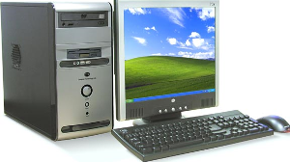
- Operating system - Microsoft Windows 7(Service Pack 1)/ Windows 10
- Hard Disk 40 GB or above
- Minimum 2 GB RAM
- Dot net Framework 4.0/4.5 Preinstalled
- USB Port

Development Tools
- Application User Interface: GUI C#.net 2015/2017
- Data Storage (DB): Sql Express 2014

Introduction
The scope of this document is to provide the understanding of this solution to all members of DNH Team & SATO Team associated with the solution development & implementation.
This document major emphasize on solution processes & user operations, where the data will be captured and afterwards will be used.
This solution major comprises of followings:
- Master Managements
- Different Types of Processes.

Login Screen
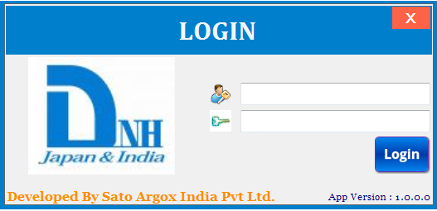

Brief Description: This screen is used for login purpose. User will enter User id & Password; system will validate entered user id & password. On the basis of entered user id & user rights assigned to user, menus of Main Menu screen will be enabled.

Main Menu
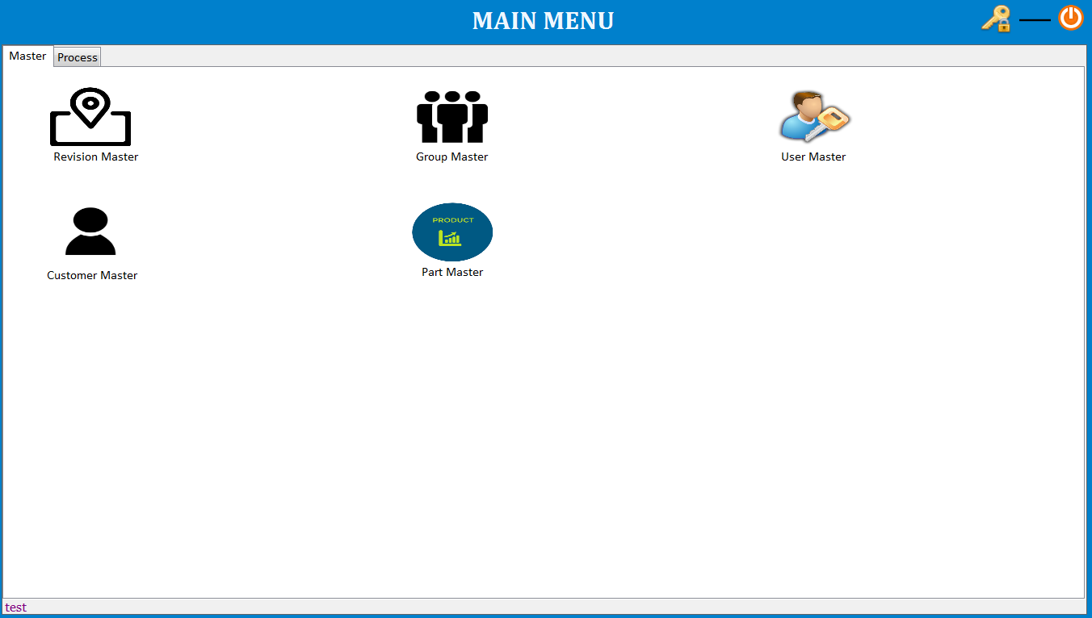

Brief Description: Main menu has two categories.
Master – By clicking on relative master menu user can navigate to different screen, like as user will click on User Master it will take to user master screen.

Process – By clicking on relative process menu user can navigate to different process screen.

Master Management

User Master
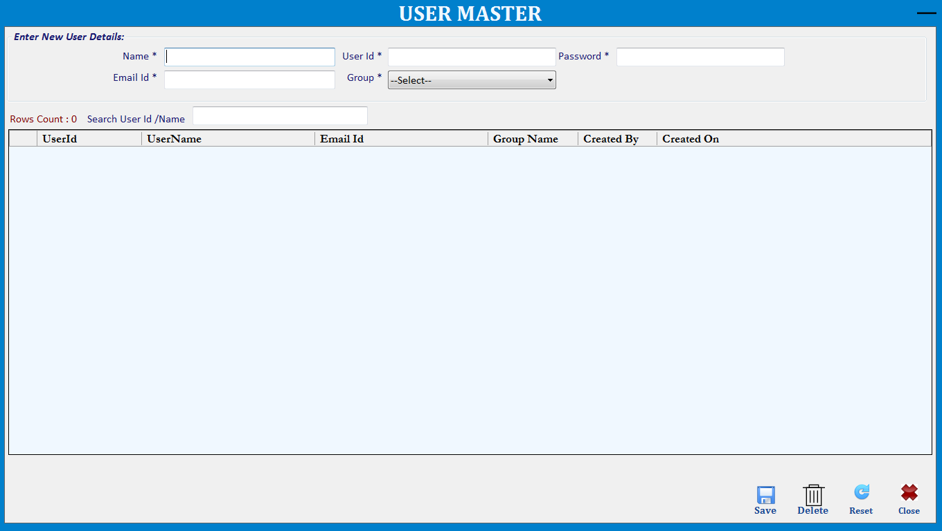

Brief Description: This screen is used to manage User via Save, Delete operations.
Note: UserId Will Be Unique.
Function Description in Detail:

Sr.No. | Function | Description | Remarks
1. | FORM LOAD | →During Form Load all data will be loaded in the Grid
2. | SAVE | →User will enter all details and click on save button to save the data.  →User will double click on any item in the grid to edit the data and click on save button to update the data.
3. | Delete | →User will double click on any item in the grid to select the data and click on delete button to delete the data.
4. | Reset | →It will clear all fields.

Group Master
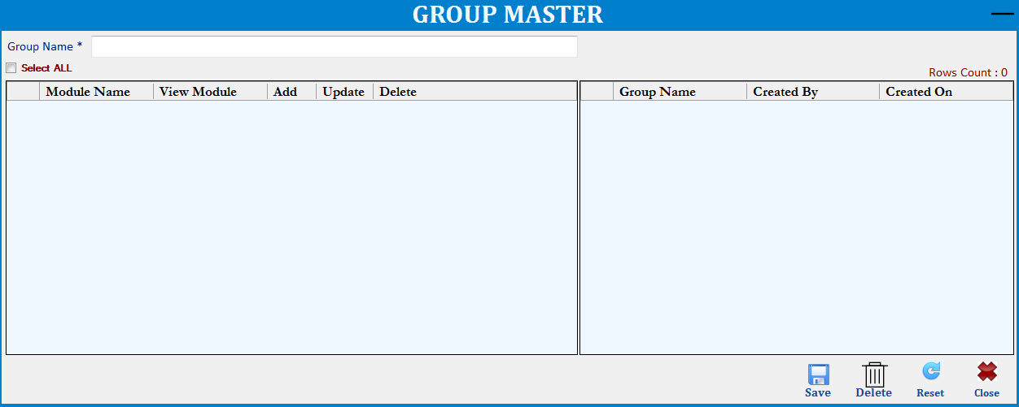

Brief Description: This screen is used to manage Group via Save, Delete operations.
Note: GroupName Will Be Unique.
Function Description in Detail:

Sr.No. | Function | Description | Remarks
1. | FORM LOAD | →During Form Load all data will be loaded in the Grid
2. | SAVE | →User will enter group name and select all the screen for which group has right and click on save button to save the data.  →User will double click on any item in the grid to edit the data and click on save button to update the data.
3. | Delete | →User will double click on any item in the grid to select the data and click on delete button to delete the data.
4. | Reset | →It will clear all fields.

Customer Master
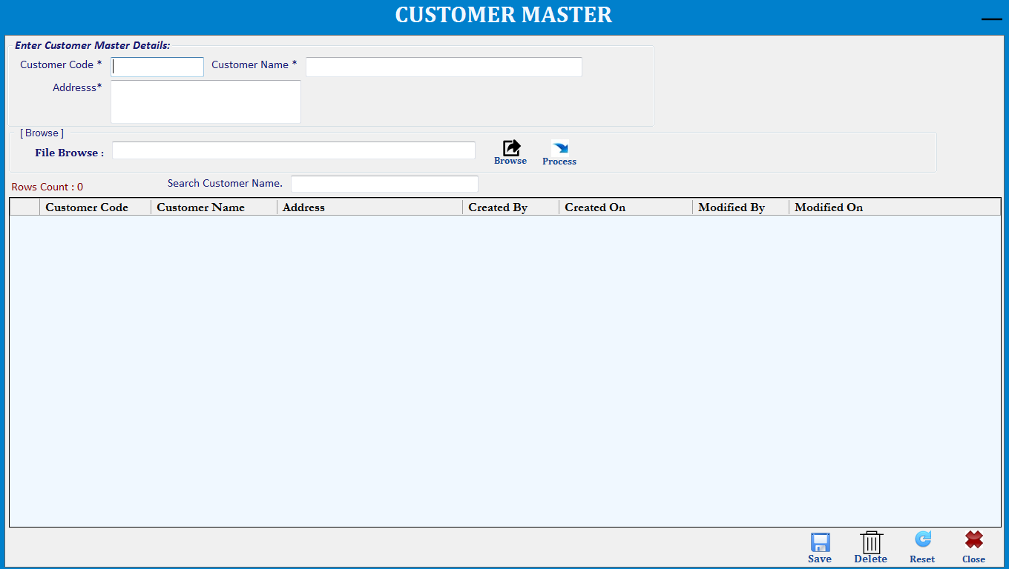

Brief Description: This screen is used to manage Customer via Save, Delete operations.
Note: Customer Code Will Be Unique.
Function Description in Detail:

Sr.No. | Function | Description | Remarks
1. | FORM LOAD | →During Form Load all data will be loaded in the Grid
2. | SAVE | →User will enter all details and click on save button to save the data.  →User will double click on any item in the grid to edit the data and click on save button to update the data.
3. | Delete | →User will double click on any item in the grid to select the data and click on delete button to delete the data.
4. | Reset | →It will clear all fields.
5. | Browse | →User can browse the customer raw data file and import one shot into database.

Part Master
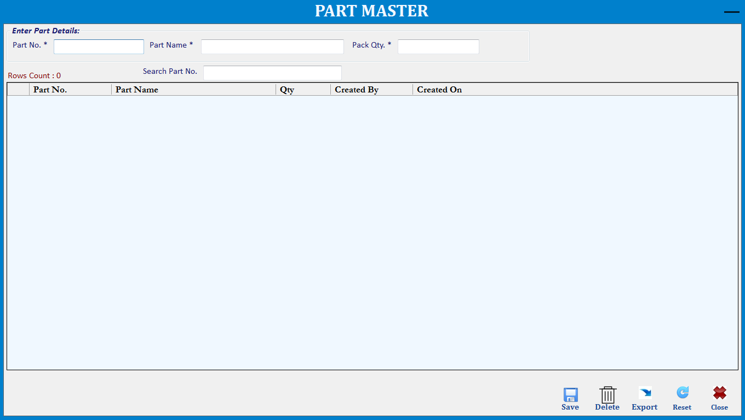

Brief Description: This screen is used to manage Part via Save, Delete operations.
Note: PartNo. Will Be Unique.
Function Description in Detail:

Sr.No. | Function | Description | Remarks
1. | FORM LOAD | →During Form Load all data will be loaded in the Grid
2. | SAVE | →User will enter all details and click on save button to save the data.  →User will double click on any item in the grid to edit the data and click on save button to update the data.
3. | Delete | →User will double click on any item in the grid to select the data and click on delete button to delete the data.
4. | Export | →User can export all part data into excel file.
5. | Reset | →It will clear all fields.

Revision Master
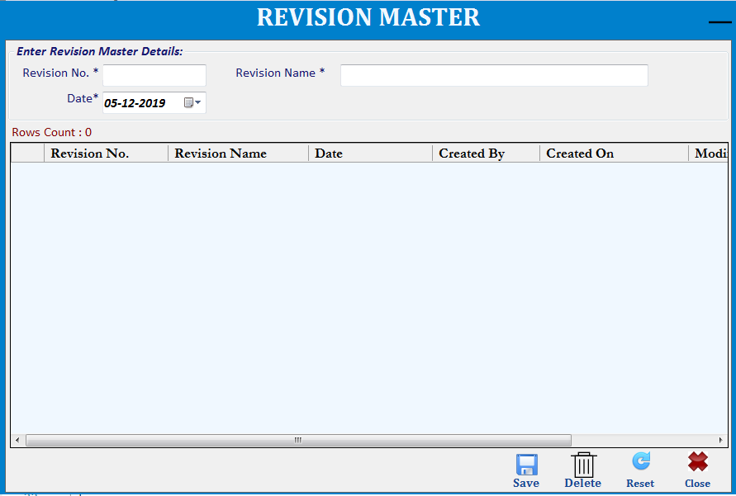

Brief Description: This screen is used to manage Revision via Save, Delete operations.
Note: Revision No. Will Be Unique and in this module user can enter only one revision entry at single time.
Function Description in Detail:

Sr.No. | Function | Description | Remarks
1. | FORM LOAD | →During Form Load all data will be loaded in the Grid
2. | SAVE | →User will enter all details and click on save button to save the data.  →User will double click on any item in the grid to edit the data and click on save button to update the data.
3. | Delete | →User will double click on any item in the grid to select the data and click on delete button to delete the data.
4. | Reset | →It will clear all fields.

Process

Label Printing
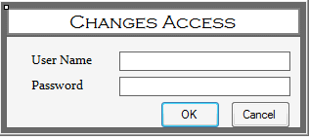
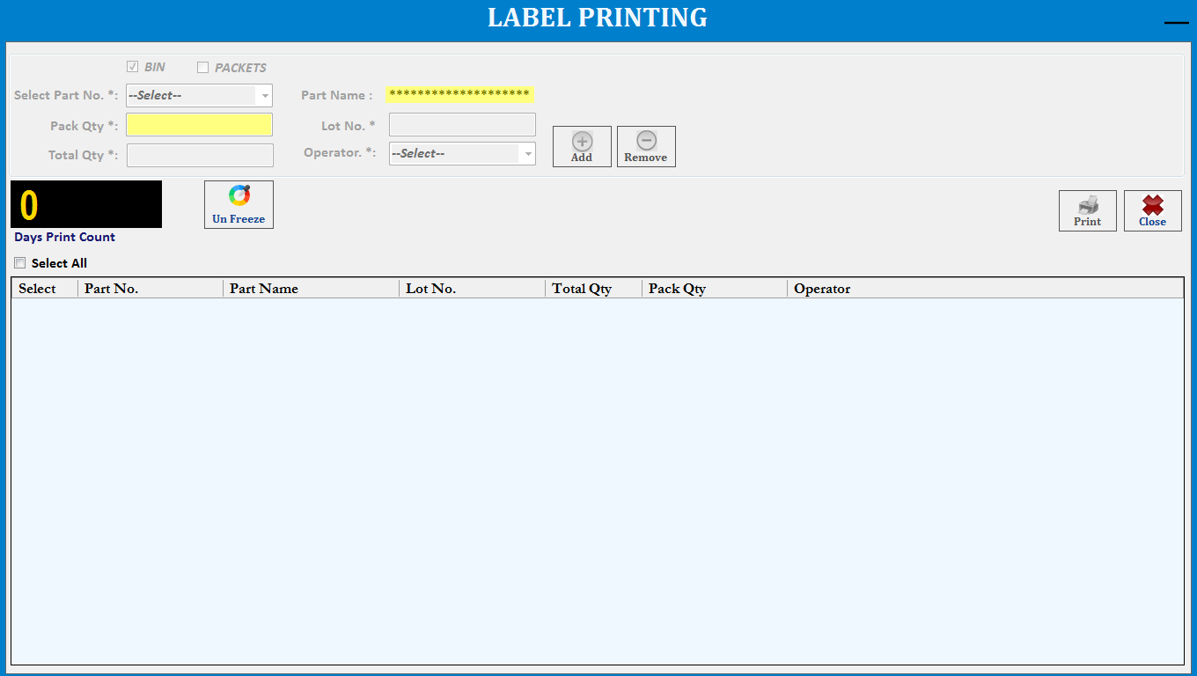
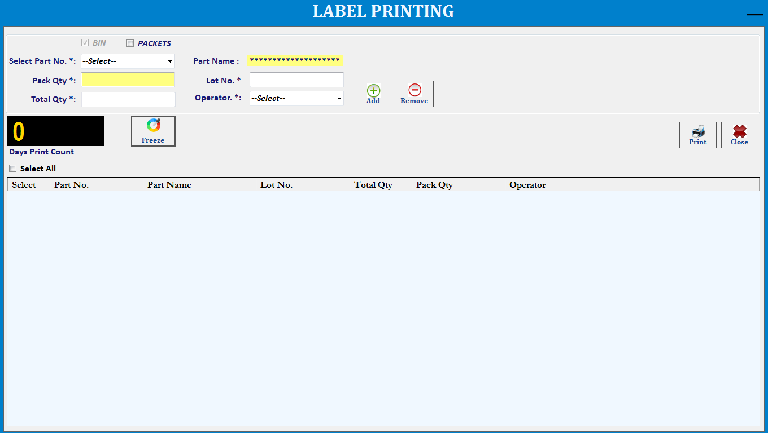

Brief Description: This screen is used to manage Print via Print operations.
Note: PartNo and Lot No combination Will Be Unique.
Function Description in Detail:

Sr.No. | Function | Description | Remarks
1. | Print | →All Label printing parameter will be freeze and supervisor click on unfreeze button then changes access screen will be display.  →Enter user id & password then.  →Part selection or any changes on the screen so supervisor/admin will enter password then can able to change the data and supervisor/admin information will be update into database.  →User will select the Part No and Operator ,enter the Lot No, Total Qty and can modify the pack also then click on Add button (Add multiple part and start the printing).  →For Remove click on remove button.  →By default, single Bin barcode will be print, when user want to print packet barcode also then need to check on packets checkbox.  →Then automatically respective fields’ data will come and Days Print Counter Increase.  →.User will print one part barcode click on print button.  →.Data will be Save in database.
2. | Reset | →It will clear all fields.

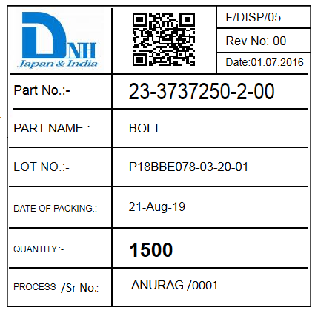

Note: 2D Barcode Data= PartNo~Qty~LotNo.~Date(DDMMYYYY)~4DigitSerialNo
23-3737350-2-00~1500~P18BBE078-03-20-01~21082019~0001

Import Picking Plan Data
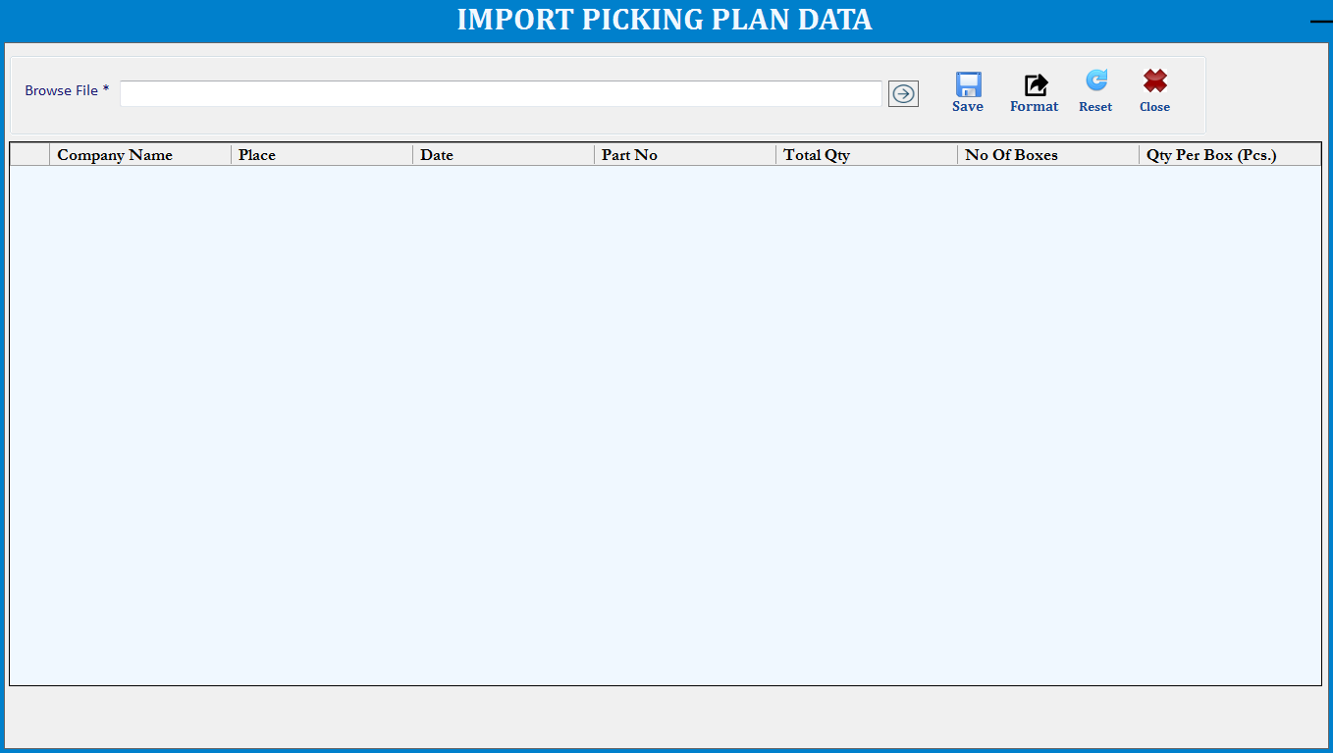

Brief Description: This screen is used to manage Import Picking file for picking operations.
Note: Company,PartNo combination Will Be Unique.
Function Description in Detail:

Sr.No. | Function | Description | Remarks
1. | Format | →User will have specific file format for uploading the packing data.
2. | Browse | →User will browse the file and data will be display in view.
3. | Save | →When user will save the file then Picklist No. will be generate and data will save into database.
4. | Reset | →It will clear all fields.

HHT Upload Data
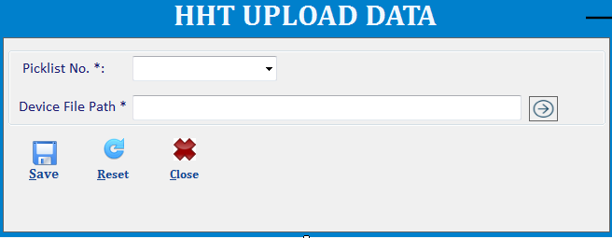

Brief Description: HHT Upload screen will be show like this.
- First all pending/to be uploaded Pickilist will be bind.
- User will select the picklist and choose the HHT Upload file path and one file will be generate name with picklist no.
- User will copy all pickilist files and manually past into HHT device into “DHN Picking Files” Directory.

HHT Main Menu
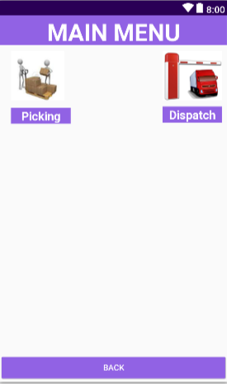
Brief Description: This screen will be two option in main menu:.

- Picking: - User will click on picking option then picking screen will be open.
- Dispatch: - User will click on dispatch option then dispatch screen will be open.

Picking
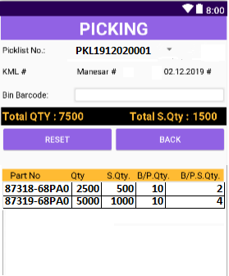

Brief Description: This screen will be used for Scanning.

- User will select Picklist No. then data will be display in view.
- Customer,Location and Picklist date will be show as below.
- User will scan the Bin barcode against the pickilist data.
- Then scan qty will be update into view and displayed label and data will be save into database.
- In addition, Barcode data will be update into HHT Picking Scan Files.

Validation Description:
- Picklist material and Qty will check with scanned barcode.
- If will not verified then below validation message display:

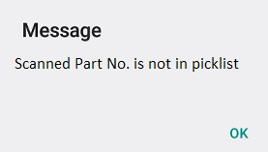
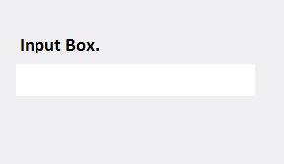
- Click on ok button then Input Box will be displayed and Admin/Supervisor will scan
Kanban barcode then further scanning will be start.

HHT Download Picking Data
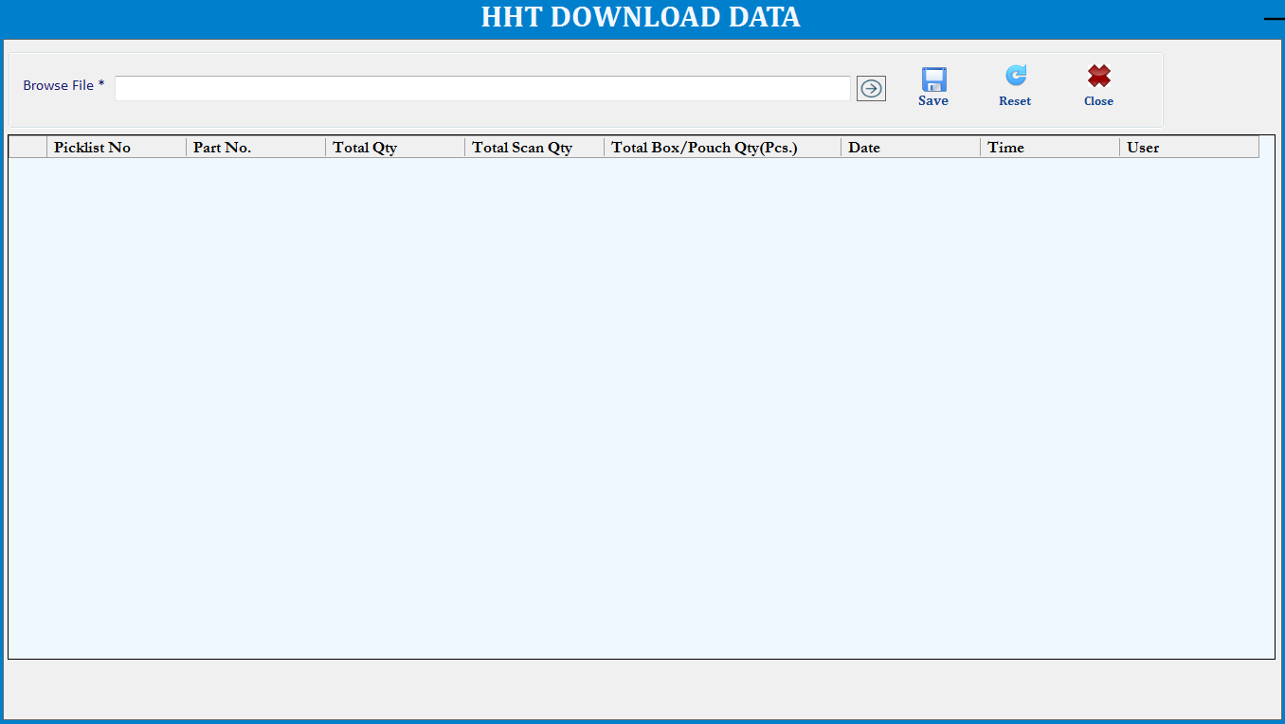

Brief Description: HHT Download will be screen show as above screenshot.
- User will copy scanned files from HHT and paste into HHT Download Directory in PC startup path.
- Using this module, user will select the all scanned files and data will be display into view.
- Click on save button data will save into database.

Dispatch (Kanban Verification)
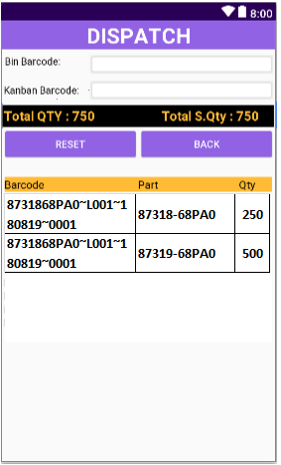

Brief Description: This screen will be used for Scanning.

- First user will scan Bin Barcode.
- Scan Kanban QR Barcode will marry of Bin Barcode data with PartNo. And Qty
- Then Bin Barcode will be update in view
- In addition, Barcode data (Bin Barcode,Status,DispatchedBy,DispatchedOn) will be update into HHT Dispatch Scan File.

Validation Description:
- Scanned Bin barcode will verify Part and Qty with Kanban barcode .
- If will not verified then below validation message display:

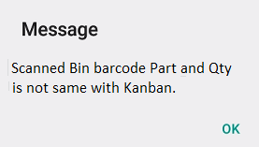
- Click on ok button then Input Box will be displayed and Admin/Supervisor will scan
Kanban barcode then further scanning will be start.

HHT Download Dispatch Data
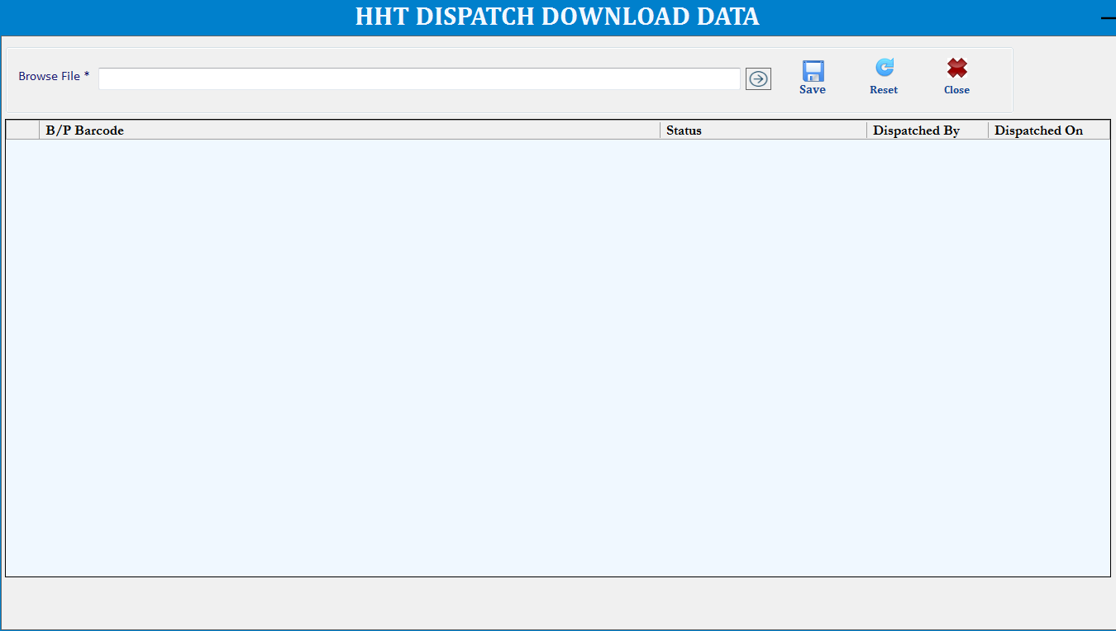

Brief Description: HHT Dispatch Download will be screen show as above screenshot.
- User will copy scanned files from HHT and paste into HHT Dispatch Download Directory in PC startup path.
- Using this module, user will select the scanned files and data will be display into view.
- Click on save button data will save into database.

Web Reports

Login
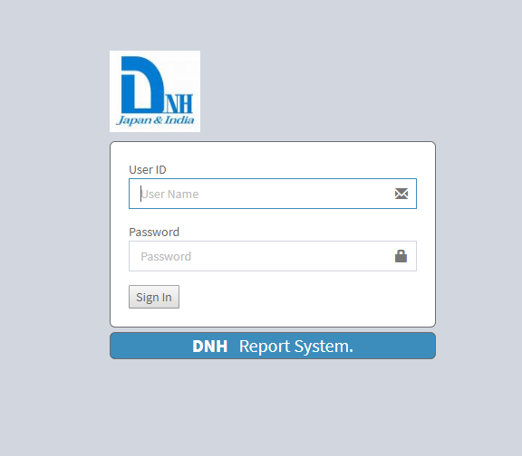

Brief Description: Login screen user will login with user id and password.

Report Main Menu
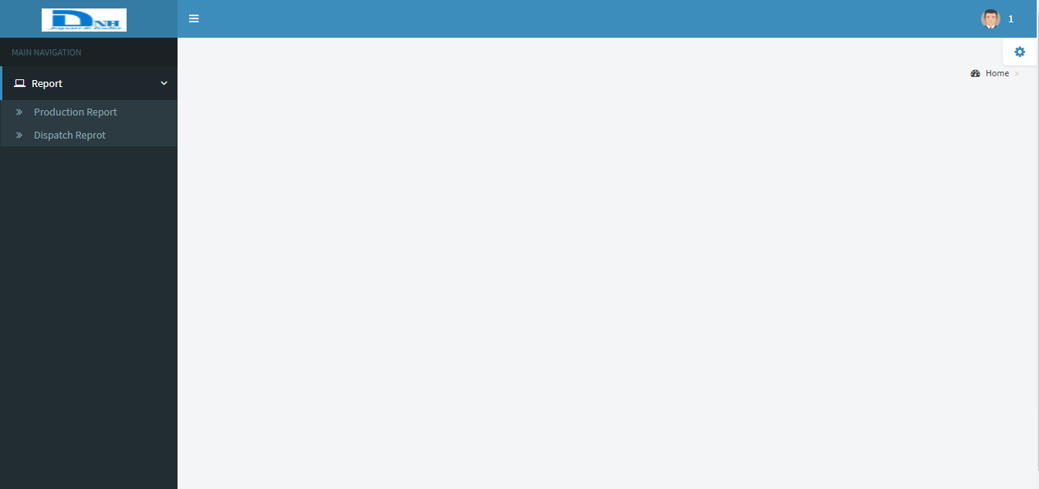

Brief Description: Main Navigation web report will be show:

Production Report
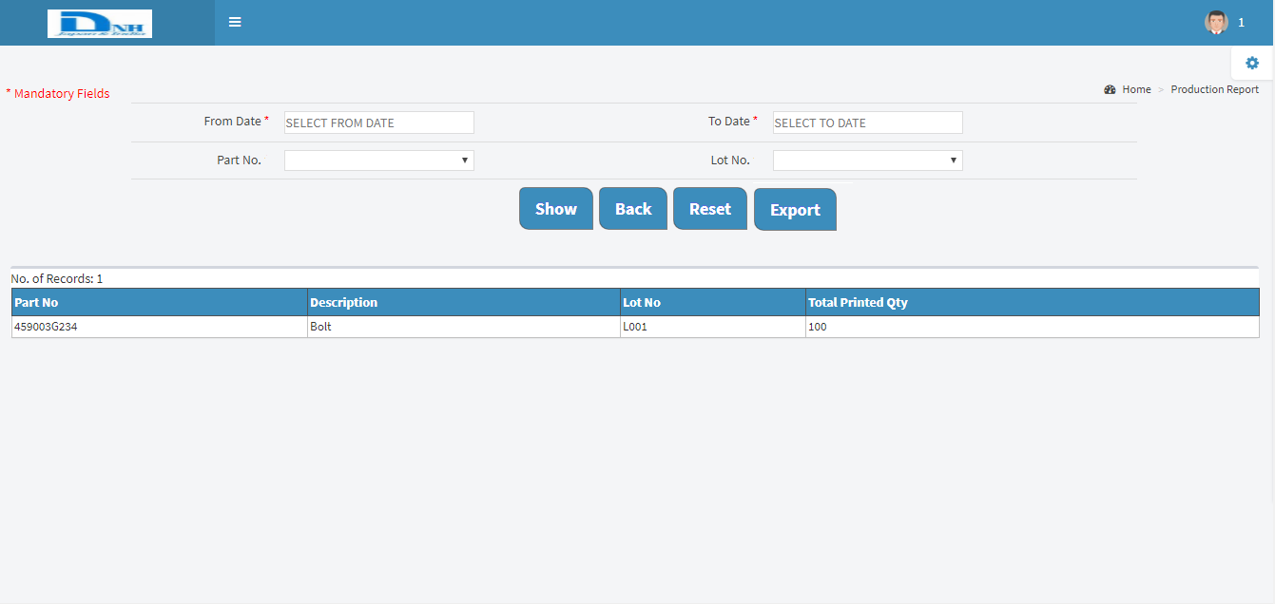

Brief Description: This report will show Printing Report related information.
- User will select from and to date then corresponding data will be display.
- Also can see Part No. and Lot No wise data will be display (Opt. Fields).

Dispatch Report
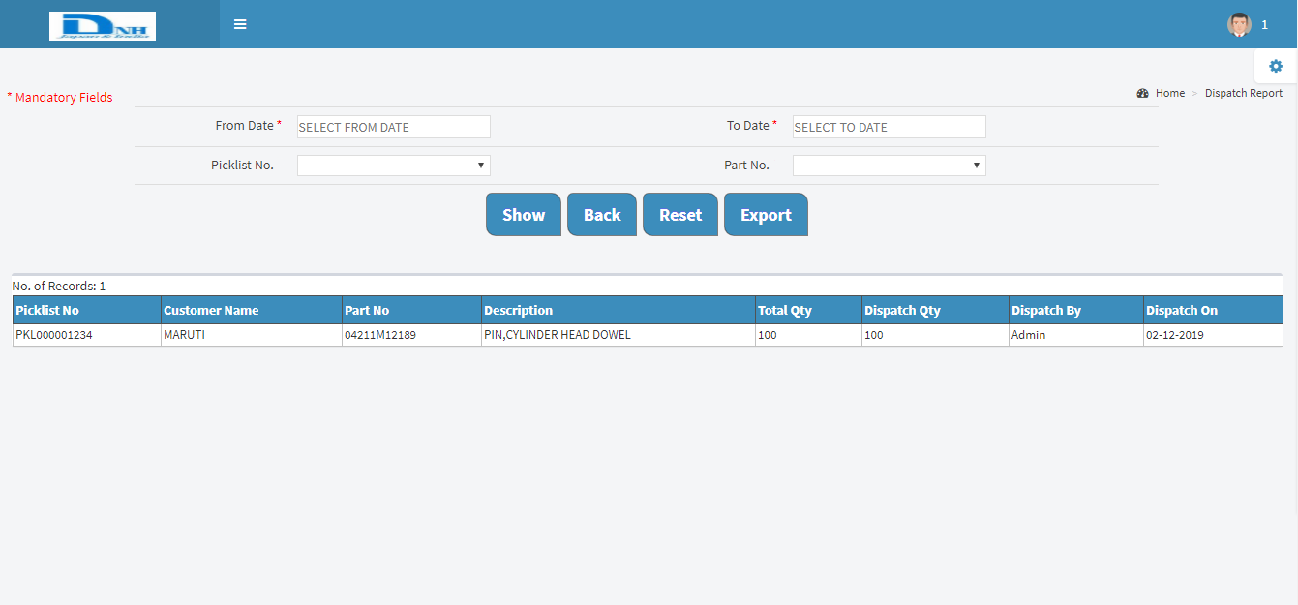

Brief Description: This report will show Dispatch Report related information.
- User will select from and to date then dispatch/Scanned data information will show.
- Also can see Picklist No. and Part No. wise data will be display (Opt. Fields).

